Wallops Specs:

- Max payload: 12 kg
- Satellite Stowed
  - Length: 38.6 cm
  - Width: 25.6 cm
  - Height: 12.7 cm
- Flight Heritage: yes
- Exit Velocity: 1.25 m/s
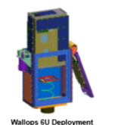
- +Y face has a large hole in it
- Pros:
  - wfqw
- Cons:
  - eqfvew

Planetary Specs:
- Max Payload: 12 kg
- Satellite Stowed
  - Length: 36.6 cm
  - Width: 23.94cm
  - Height: 10.66 cm
- Flight Heritage: yes
- Exit Velocity: Dependent On mass of LV and Payload
- Required to have tabs on structure to be secured in deployer

